

**Induction Pack for Schools:**

**support for newly arrived pupils with English as an additional language**

**Contents:**

**Part One: Introduction and Rationale**

1. Introduction

2. Key messages and definitions

3. New arrivals in the Bradford District

4. Conditions for learning

**Part Two**

1. EAL pedagogy

2. Developing an additional language: BICS and CALP

**Part Three: Preparing for New Arrivals**

1. New arrival flowchart

2. Induction checklist

3. Subject Area Signs

4. Signs for school day activities

**Part Four: EAL Initial Assessment and Intensive Language Support**

1. Initial EAL assessment models

2. Targets and teaching strategies

3. Individual Language Plan (ILP)

**1. Introduction**

This pack of resources represents a comprehensive approach to addressing the issues facing schools as they make their preparations to welcome New Arrivals and give them the best possible start to their schooling in the UK.

The pack is based on examples of best practice locally and nationally; Therefore, reference will be made to resources and guidance documents such as the New Arrivals Excellence Programme and teaching materials from colleagues in the Local Authority and elsewhere.

This guidance focuses primarily on meeting the needs of pupils who have arrived in school as a result of international migration. However, the guidance may be more widely applicable to a number of groups of mobile pupils who arrive in school outside standard admission times.

**2. Key Messages**

When catering for the needs of New Arrivals it is important to recognise the following:

* diversity and richness of experience and expertise that New Arrivals bring to school
* Newly arrived pupils come with a range of cultural, linguistic and academic needs that need to be met through different forms of representation of their language, culture and identity
* Welcoming New Arrivals needs a whole-school approach. Schools need to ensure they have carefully considered, and if necessary formalised, their welcome and induction procedures through for example, an Induction Policy
* Some cultural values and practices may be different from those of the teacher
* Children need to have the freedom to use their own languages and to code-switch when necessary
* New arrivals may need a range of ‘scaffolds’ to support learning and that the degree of support needed will vary over time, context and degree of content complexity
* that children will need time and support so that they do not feel pressurised
* that supportive attitudes of peers may need to be actively fostered
* It may be difficult to assess children’s real achievements and that the active involvement of parents will make a great deal of difference, as will ongoing monitoring.

Definitions

**New arrivals**: New arrivals may be described as:

* **International migrants** – including refugees, asylum seekers and economic migrants from overseas.
* **Internal migrants** – including pupils joining the school as a result of moving home within the UK, for example, Gypsy, Roma and Traveller pupils.
* **Institutional movers** – pupils who change schools without moving home, including exclusions and voluntary transfers.
* **Individual movers** – pupils who move without their family, for example looked after children and unaccompanied asylum seeking children.

This guidance focuses primarily on meeting the needs of pupils who have arrived in school as a result of international migration. However, the guidance may be more widely applicable to a number of groups of mobile pupils who arrive in school outside standard admission times.

**EAL** stands for English as an additional language and recognises the fact that many children learning English in schools in this country already know one or more other languages and are adding English to that repertoire.

**Bilingual** is used to refer to those children who have access to more than one language at home and at school. It does not necessarily imply full fluency in both or all of their languages.

**Minority ethnic group** is used in this publication for all those groups other than the white British majority. Although children from these groups may well form the majority in some school contexts, they are still members of groups in a minority nationally and will continue to be referred to as children from minority ethnic groups. Most children learning EAL are from ethnic groups. School Census data shows that only a very small percentage of EAL learners are white.

**3. New arrivals in the Bradford District**

The Bradford District has had a significant minority ethnic population since the 1960s and due to its industrial heritage has had migration for many years previously. Families have re-located to Bradford from all over the world for a variety of reasons. Many of those who came in earlier waves of migration have settled here successfully and see Bradford as their home.

One of the most recent groups of people to come to Bradford are from Central and Eastern Europe. Their status is that of economic migrants but the expectation is that the majority will settle here and become part of Bradford’s diverse community. Most have come from Slovakia, the Czech Republic and Poland. The vast majority of the Slovakian and Czech families come from a Roma background. There are smaller numbers of Polish, Romanian and Hungarian Roma families.

There are also families seeking Asylum and those who have been successful in their application for asylum and been granted Refugee status (due to **a** well-founded fear of persecution due to race, religion, nationality, political opinion or membership of a social group in their country of origin) who have moved to the district.

The following numbers of children and young people are currently (July 2012) on roll in Bradford District schools and nurseries:

* One hundred and fifty Asylum Seekers from many parts of the world including Pakistan, the Congo and China
* Two thousand two hundred and twenty two EU Migrant Workers from Central and Eastern Europe i.e. Slovakia, Poland, Czech Republic and Romania
* Three hundred and seventy eight Refugees from many parts of the world including Burma, Somalia, Iraq and Zimbabwe.

**As with other ethnic minority children and young people those from recent migrant communities enhance the school community bringing with them rich diverse cultural heritages and helping school communities to have broadening horizons of the world.**

**4. Conditions for EAL Learning**

Practitioners provide supportive conditions for children learning EAL when they:

• Understand and empathise

• Recognise the central role of relationships

• Have high expectations

• Build confidence and self esteem

• Are consistent and fair

• Model and promote values, attitudes and behaviour supportive of equality

• Value diversity and bilingualism

• Encourage children to be active and collaborative constructors of knowledge

• Recognise parents/carers as key partners

• Listen and learn

Conditions for Learning - Essential Understandings

• Children need to feel safe, settled, valued and secure – they need a sense of belonging.

• Learning should build on what children know, understand and can do.

• No child should be expected to cast off the language and culture of home as s/he crosses the school threshold [Bullock Report].

**5. EAL Pedagogy**

The new Teachers' Standards (DfE, 2011) which apply to all qualified teachers note that every teacher must:

*'Adapt teaching to respond to the strengths and needs of all pupils’.* They must *'have a clear understanding of the needs of all pupils, including those with special educational needs; those of high ability; those with English as an additional language; those with disabilities; and be able to use and evaluate distinctive teaching approaches to engage and support them'.* (Standard 5)

To meet the new Teachers' Standards, all teachers and trainee teachers will benefit from an understanding and recognition of EAL as a significant field of teaching and learning.

EAL pedagogy is the set of systematic teaching approaches which have evolved from classroom based practices in conjunction with the development of knowledge through theoretical and research perspectives. These approaches meet the language and learning needs of pupils for whom English is an additional language. They can be used in a wide range of different teaching contexts.

Teachers who have acquired expertise in EAL, whether they are specialists or class or subject teachers, will:

* understand progression in additional language learning;
* be able to assess pupils' understanding of curriculum content and use this information in their planning;
* draw on pupils' bicultural and bilingual knowledge and experience;
* incorporate first language knowledge and use appropriate staff resources where available;
* take account of the variables that apply in different contexts, and capitalise on the potential for working in partnership with their mainstream or specialist colleagues.

Contextual support for children learning EAL includes:

* opportunities to build on previous experience;
* teacher or practitioner modelling;
* use of visual props and realia;
* key visuals such as diagrams and time lines;
* opportunities to work collaboratively in mixed-ability groups;
* opportunities to use the first language;
* planned opportunities to listen and speak in a wide range of situations across the curriculum. par1

**Good teaching practice for pupils learning EAL**

**As an overview:**

* Use visuals, actions and real objects to attach meaning to language
* Use active, practical tasks
* Plan opportunities for speaking and listening
* Vary the activities in a lesson
* Identify key vocabulary and teach it explicitly
* Provide good models of language
* Use home language where possible
* Remember it is tiring learning in another language!

**In greater detail, this means:**

**Home Language**

* Learning a few words in relevant languages, particularly greetings
* Let students teach staff and other students some words in their home languages
* Encourage parents to continue using home language with students at home
* Making labels and signs in relevant languages
* Encourage the pupils to share their knowledge about their first language – script, basic phrases and greetings, who they talk to in which languages, where their language is the official language etc
* Encourage pupils who share the same first language to talk together in first language
* Make sure other pupils see that you respect and value pupils’ bilingual competence

**Speaking and Listening**

* Make sure that students’ names are pronounced properly
* Be a good language role model by speaking slowly to students, but in a natural voice
* Allow students to be silent until they are ready to speak in English –remember that students can understand what is said before they can express themselves fluently. Make sure they are participating by using actions/drawing/writing to demonstrate they are listening
* Allow sufficient wait time for responses and ensure opportunities for the pupils to model responses
* Encourage productive language such as hello and goodbye
* Use a graduated approach to questioning, starting with closed questions initially, and moving on to more open questions as the pupil’s language proficiency develops
* Provide activities where there is a degree of repetition
* Try to be consistent with your vocabulary e.g. decide whether to use ‘tray’ or ‘drawer’ and try not to switch
* Listen to yourself when you are talking to the new child. Watch out for confusing colloquialisms
* nvolve the new arrival in lots of opportunities to listen to English and to interact with peers in collaborative activities e.g. buzz groups, jigsaw, talk partners, summarising what their partner has said etc

**Reading**

* Choose texts with clear print and illustrations and that are representative of all students’ backgrounds and experiences
* Support the introduction of new texts with visual aids and artefacts
* Use bilingual classroom assistants/support workers/EAL teachers to introduce a new text to pupils, for example by telling the story or explaining the text in the home language, or introducing new texts in a short warm-up session
* Provide lots of guided support by getting students to produce storyboards for a particular text, or use writing frames
* Revisit texts in paired reading sessions, pairing bilingual learners with fluent speakers of English
* Spend more time discussing the meaning of words, especially examples of idiomatic language
* Use sentence level work to develop students’ understanding of grammar such as tense and the use of prepositions
* Make books available to take home

**Writing**

* Build in oral practice before written work
* Show examples of requirements before task
* Labelling pictures
* Matching text and visuals
* Cloze procedure – filling in gaps in sentences or paragraphs
* Text highlighting or underlining
* Sequencing sentences to form a short, continuous piece of writing, which can then be written out
* Using writing frames which provide structure for a text
* Compiling a glossary of subject specific vocabulary provided by the teacher, including pictures and/or translations
* Using ICT that supports understanding
* Encourage students to write about themselves, their home country and present circumstances, keep a diary or make a scrapbook or picture book about themselves. These techniques help develop understanding of complex events and feelings.

**Focused group work**

* Group the EAL pupils according to their cognitive ability and not their language ability, and with good language models, not with pupils with SEN
* Provide scaffolding materials, such as picture prompts, word cards/bank, sequencing cards, tapes, bilingual dictionaries, picture dictionaries, adapted worksheets (e.g. cloze passage with picture substitutions)
* For new arrivals who speak very little English, provide intensive English support daily for 20 minutes to teach them the basics
* At times let pairs of students develop and teach mini ‘lessons’ to the new arrival, such as teaching how to tell the time. This can be just as beneficial for the ‘teachers’ as the learners

**Practical activities**

* Play lots of language rich games with students e.g. barrier games, enquire and eliminate, 20 questions etc
* Provide opportunities for play
* Baking, dance, drama, PE all provide wonderful opportunities for developing vocabulary

**Celebrating diversity**

* Tell folk-tales from the students’ countries of origin and invite parents or others from the community to tell stories
* Use books and toys that depict people from different ethnic groups
* Celebrate various faiths

**Position in classroom**

* Sit the pupil next to sympathetic members of the class, preferably those who speak the same language and can translate or a well-behaved English-speaking child who will provide a good role model
* Sit the pupil near the front of the class and to the side so they can be near the teacher and also can see the other students speak

**Teaching aids**

* Provide a high level of visual support, for example mime, gestures, videos, slides, pictures, photographs, diagrams, flashcards and illustrated glossaries
* Use of key visuals such as mind-maps, spider diagrams, word roses, timelines, Venn diagrams, graphs, flow charts etc
* If the pupil is literate in home language, encourage the use of a bilingual dictionary as much as possible
* Provide the students with personal wordbooks in which they record words as they are introduced
* Spend more time discussing the meaning of words, especially examples of idiomatic language
* Use sentence level work to develop students’ understanding of grammar such as tense and the use of prepositions
* Encourage students to write about themselves, their home country and present circumstances, keep a diary to make a scrapbook or picture book about themselves.
* These techniques help develop understanding of complex events and feelings. [Younger students can use paints and crayons to draw about themselves and work with an adult to write down captions to their drawing.]

**Planning**

* Where possible plan collaboratively with EMA staff, and support assistants
* Ensure effective communication of planning to other adults where collaboration is not possible

Plan for inclusion by differentiating planning using strategies outlined above

**a) Activating prior knowledge in the pupil**

**Rationale**   
Bilingual pupils' experiences will vary, as will their use of English and knowledge of culturally specific frameworks for learning. Learning involves integrating new information ('input') into their existing mental model of the world (or schema). In second or additional language learning, prior knowledge of content and language plays a major role in helping to make additional language input comprehensible.

**Examples:** Finding out what pupils know about a topic through questioning, supporting self-monitoring and using KWL (Know, Want to find out, Learned) charts, brainstorming in small groups or pairs, discovery tasks, enabling use of first language.

**b) The provision of a rich contextual background to make the input comprehensible**

**Rationale**Pupils learning EAL require opportunities to draw on additional contextual support to make sense of new information and language. Content learning for pupils learning EAL can be greatly improved through the use of visual support. This can help learners to conceptualise learning tasks that are being presented to them, or in which they are engaged, even when their knowledge of the target language is limited.

**Examples:**

There is a distinct difference between a visual aid (for example, a picture of a frog) and 'key visuals' (for example, a diagram of the life cycle of a frog). Key visuals or graphic organisers are linked to tasks which support the development of conceptual and language knowled also offer opportunities for pupils to engage in active learning experiences. Visual support and graphic organisers might include: maps, diagrams, charts, tables, semantic webs, graphs, time-lines, outlines of causal sequences, videos, computer graphics, web pages etc.

**c) Actively encouraging comprehensible output**

**Rationale**   
Learners are actively encouraged to produce spoken and written language from an early stage of the lesson(s) onwards. This is important for both cognitive and linguistic development. The active use of language provides opportunities for learners to be more conscious of their language use, and to process language at a deeper level. It also brings home to both learner and teacher those aspects of language which will require additional attention.

**Examples** Using peer tutoring, collaborative learning, drama and role play, opportunities for scaffolded teacher-pupil and pupil-pupil interaction, using oral feedback to move learners towards the forms of language used in writing, questioning strategies.

**d) Drawing the learner's attention to the relationship between form and function; key grammatical elements are pointed out and made explicit**

**Rationale**   
Whatever language is needed to talk about the content, it should be used in ways that allow learners to take note of the language itself. Attention should be drawn to language and how it is used to express the content knowledge. This can mean explicit comment on forms, structures and functions of the language that is used to convey the content, as well as in more indirect ways of calling attention to language.

**Examples**Drawing attention to the grammatical forms used to recall past events or to express doubt (e.g. 'may' and 'might') in texts, modelling and extending its use, providing opportunities for practice; talking about ways of expressing politeness when asking for something; noting how paragraphs present information in different subjects; how subtitles are used.

**e) Developing learner independence**

**Rationale**Learners need increasingly to become more independent in their use of a range of learning strategies, drawing on metacognitive (e.g. organisational planning), cognitive (e.g. grouping/classifying) and social-affective (e.g. co-operation) awareness. The teacher has a key role in encouraging pupil independence through the selection of planned activities, and by assisting learners to apply strategies which develop self-reliance.

**Examples** Providing opportunities to model and extend what has been taught; scanning texts to look at sub-headings and diagrams prior to reading; using diagrams to demonstrate knowledge; using dictagloss; note-taking; teaching study skills.

**f) Deciding which language items to teach**

**Basic vocabulary, language functions and sentence patterns**

**i) Basic vocabulary areas:**

The vocabulary items that could be taught are endless. Often we will be guided by the curriculum of the whole class and teach beginners key vocabulary items that relate to the lesson topic; for example, if the topic is electricity we might focus on the basic vocabulary of the topic e.g.

wire/crocodile clip/battery/bulb/positive/negative/etc.

However, when pupils are newly arrived in school, it is often helpful to focus on a few practical areas of vocabulary that they will need immediately in their life in school. The following list is not comprehensive but does indicate the sort of vocabulary that might be taught in the first few weeks.

|  |  |
| --- | --- |
| **vocabulary areas** | **examples of words to be taught** |
| 1. social language | please thank you sorry hello goodbye etc. |
| 1. classroom objects | pencil rubber book board chair table carpet tray folder door felt-tip paint scissors glue rubber ruler milk crisps etc. |
| 1. areas of the school | classroom hall playground toilet dining hall office stairs staff-room library corridor car-park upstairs downstairs etc. |
| 1. school routines | assembly/playtime/dinner time/whistle/home time/ etc. |
| 1. clothes | shoes dress coat trousers trainers shorts swimming costume towel shirt blouse vest pants T-shirt socks jumper etc. |
| 1. parts of the body | head face eyes ears hair nose mouth teeth tongue  body arms hands legs feet etc. |
| 1. health | tummy ache/toothache/earache/cut/bleed/hurt/broken/etc. |
| 1. colours | black white red blue green yellow (beware colour blindness) |
| 1. people | girl boy man woman children teacher etc.  names of the teacher, headteacher, other children, other adults in the class, etc. |
| 1. family | mother father sister brother |
| 1. reading | book page word picture story etc. |
| 1. Maths - counting | 1 - 10, 10 - 20, 20 - 100, etc. |
| 1. Maths - money | pound penny |
| 1. Maths - computation | add take away multiply divide more less etc. |
| 1. Maths - shapes | square circle triangle rectangle etc. |
| 1. Maths - measuring |  |
| 1. meals/food | breakfast, dinner, tea, supper food usually served for school dinners, other food as necessary |
| 1. meals/utensils | plate knife fork spoon bowl rubbish bin cup saucer mug etc. |
| 1. instructional verbs (classroom) | sit down/stand up/stand still/write stop draw colour paint listen line up go and get/show me your/stick/ etc. |
| 1. instructional verbs (PE) | jump hop climb roll throw catch etc. |
| 1. street (nouns) | road pavement zebra crossing traffic lights etc. shop house car lorry van etc. |
| 1. street (verbs) | look cross stop be careful go etc. |
| 1. time | now yesterday tomorrow last week next week dinner time play time home time 9 o’clock half past seven etc. |
| 1. House - outside/rooms | roof door wall garden etc. sitting room/bedroom/kitchen etc. upstairs downstairs |
| 1. House - furniture | bed bath cooker etc. |
| 1. day/months | Monday, Tuesday, March, April, etc. |
| 1. weather | cold hot rain sunny etc. |

We can also extend the vocabulary listed above e.g.

|  |  |
| --- | --- |
| body | fingers toes shoulders knee ankle wrist bottom stomach lips back |
| colours | grey pink brown silver gold orange |
| clothes | gloves scarf plimsolls sweater sweatshirt hat cap |
| family | grandfather cousin aunt uncle etc. |

**ii) Functions and sentence patterns**

As well as teaching individual words, it is important that pupils are taught sentence patterns. The following lists some key language functions and associated sentence patterns that are useful for beginners.

|  |  |
| --- | --- |
| **Functions** | **Sentence patterns** |
| Identifying objects | What’s this? It’s a ..... What are these? They’re ....  Is this a ....? Yes it is/Not it isn’t  Are these ....? Yes they are? No they aren’t |
| Polite English   1. asking for things 2. asking for permission 3. apologising | Can I have a/some ..... please?  Can I go/etc. to ..... please/  I’m sorry. Excuse me. |
| Identifying actions | What are you doing? I’m ......ing  What is she/he doing? S/he’s ....ing  Are you .....? Yes I am/No I’m not.  Is s/he ....ing? Yes s/he is/No s/he isn’t. etc. |
| Locating objects | prepositions:-  Where’s the/my/your ....?  It’s here/there It’s on/in/under/beside/etc. |
| Describing problems | What’s the matter?  I’ve hurt/lost/broken ......  My ...... hurts/is broken/is missing/etc. |
| Expressing likes/dislikes | Do you like .....?  Yes I do/No I don’t. |
| Expressing possession | That’s mine/his/her/ours/etc.  I’ve got a ....... /Have you got a .......? Yes I have/No I haven’t |
| Describing objects | What colour is this ....? It’s red/blue/etc.  How big/long/wide is this .....? It’s ... cm long/wide.  They’re the same/different.  What’s it made of? It’s made of wood/paper/etc. |
| Counting | How many ... are there? There is/are ...1/2/3/etc.  a lot/many/some/a few/etc. |
| Describing ability | I can ...../Can you ....? Yes I can/No I can’t. |
| Reporting and narrating | simple past tense:-   1. I went/saw/played etc. 2. Did you **go/see/play** etc.? Yes I did/No I didn’t.   yesterday, last week |
| Describing lifestyles and regular events | What does a chemist/bus driver/etc. do?  What do you do after school? etc. |
| Predicting the future | I’m going to be an astronaut/film star/zoo keeper ...  We will look at that tomorrow.  I’m holding a party on Saturday. etc. |
| Referring to past and present | I’ve hurt/broken/lost my .......  Has s/he gone/seen/written etc. |
| Expressing obligation | You must/mustn’t/have to/ought to/should |

Reference: Key Strategies for a language enhancing curriculum, Beginners to English, Gordon Ward Nottingham LEA

**6. Developing an Additional Language: BICs and CALP**

Additional language development would appear to proceed in an orderly fashion. Researchers have discovered that there is a fairly common sequence of acquisition for additional language learners across a range of languages and contexts. What is not known is exactly what aspects of the additional language are learned in what sequence. However it is known that some aspects are learned when there is a perceived need by the learner and some items can be learned in no particular sequence. Other research has suggested that there is a developmental sequence which precludes the early learning of certain items. Additional language learners will demonstrate some of the stages of first language development. For example, they may go through a period when a rule is generalised to all instances. However, the rate of acquisition and the level of proficiency achieved in additional language learning will depend upon the individual learner.

**BICS and CALP Matrix**

This represents one of the most successful models of additional language acquisition and a useful tool for planning additional language provision. Jim Cummins (1984) believes that the process of additional language acquisition takes place within the framework of a quadrant as illustrated below. This quadrant can be used not only as a planning tool for additional language provision, but also as an illustration of the process of additional language acquisition. In other words, while this can be used by teachers in their planning for additional language support it also shows the path that a additional language learner follows starting with the beginner stage, bottom left hand corner (A) through to the advanced bilingual stage, top right hand corner (C). The model warns against any provision that falls into the last part of the quadrant, bottom right hand corner (D) where tasks can be both undemanding and abstract, would have little, if any, learning potential. Copying from the board is an example of activities in this part of the quadrant.

**BICS and CALP Matrix**

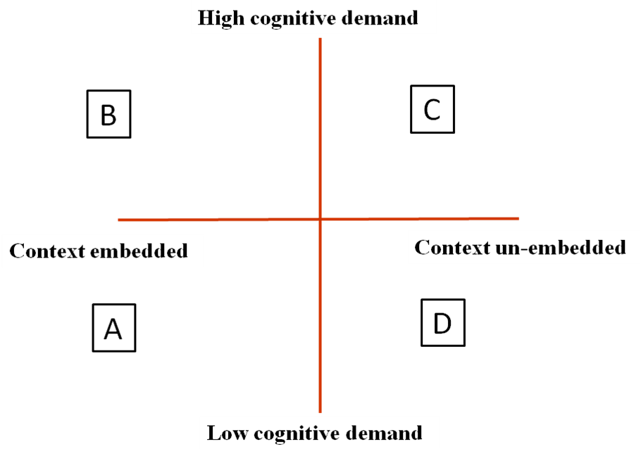

The horizontal axis of the BICS/CALP matrix represents a continuum from 'context-embedded' to 'context-reduced', ranging from the situation in which the learner uses external clues and information, such as facial gestures, real objects and pictorial representation to enable understanding, to the other extreme where the learner must rely on linguistic cues, and knowledge about language and text to understand meanings. The vertical axis relates to the degree of cognitive involvement in a task, and moves from tasks that are not very demanding to increasing challenging activities.

The matrix shows that a additional language acquisition learner follows a trajectory starting from part A of the quadrant where activities are ‘cognitively undemanding and context-embedded’, for instance, matching words to a picture, identifying objects or retelling a story. These activities might be appropriate for a beginner who at this stage is trying to develop what Cummins refers to as ‘Basic Interpersonal Communicative Skills’ (BICS). In other words, this is the process of acquiring conversational fluency and the skills of using everyday language which may take up to two years. The learner then moves to part B of the quadrant where activities are more ‘cognitively demanding and context-embedded’. This means that the degree of challenge is increased while support is still maintained. This is best achieved through tasks asking the learner to compare, summarise, generalise or transform. Finally the learner reaches the stage of becoming an advanced bilingual learner (part C of the quadrant) where tasks are more challenging and with very limited support. Activities such as hypothesising, analysing and justifying are characteristics of operating at this stage which Cummins refers to as the stage of developing Cognitive Academic Language Proficiency (CALP) i.e. the use of language in decontextualized academic situations This allows a additional language learner to achieve a level of academic linguistic proficiency comparable to monolingual target language speaking peers and it may take up to seven years to reach this stage. The two illustrations below show the process of additional language acquisition and how this may be used as a tool for our planning of additional language support.

1. **BICS and CALP Matrix and language acquisition process**

**C**

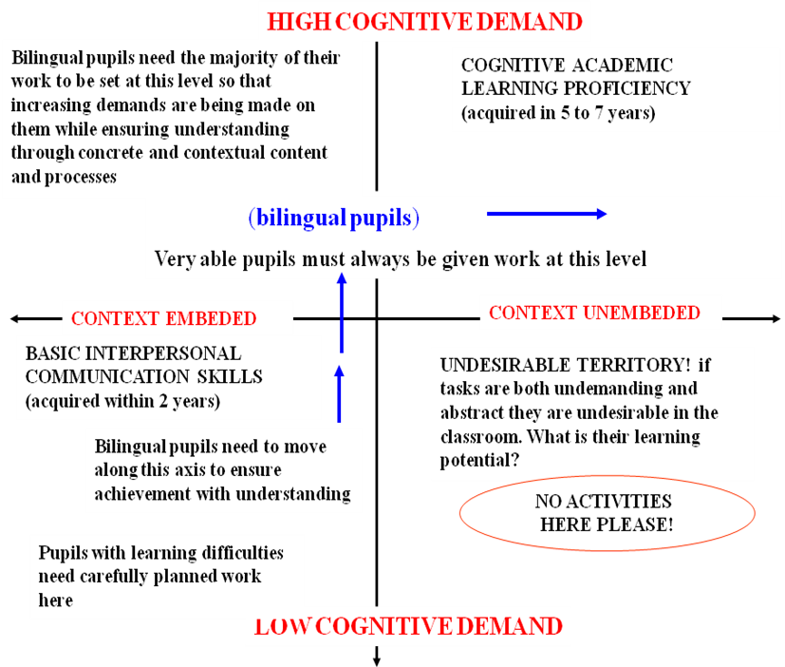

**B**

**D**

**C**

1. **BICS and CALP Matrix as a planning tool**

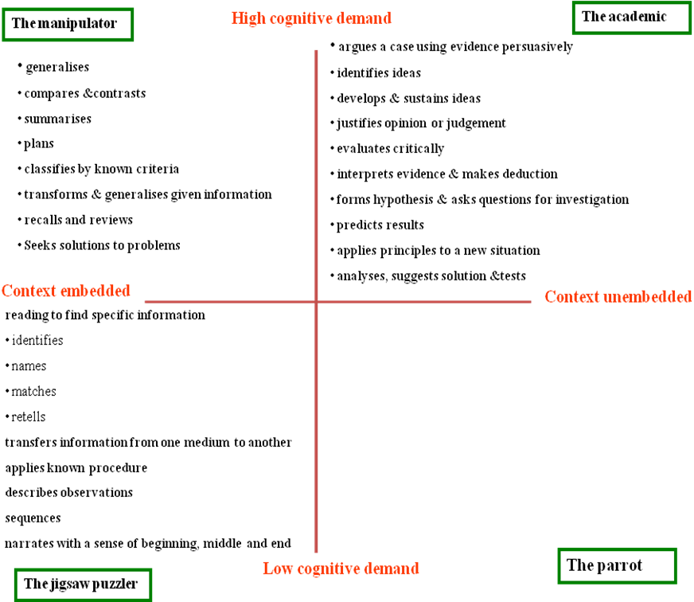

Cummins' model has proved helpful in identifying and developing appropriate tasks for bilingual pupils. For example, in preparing tasks for a newly arrived additional language learner, teachers might start with contextualized tasks and practical activities that are of low cognitive demand, such as naming items or a simple matching exercise. More proficient learners would require contextual support, but would need more cognitively demanding tasks. This approach to planning and assessing EAL learners was developed and reported in Cline and Frederickson (1996).

**Common Underlying Proficiency**

It is often the case that being literate in a first language helps in a considerable way in learning a additional language. In order to explain and justify this conclusion, Cummins (1984 and 2000) argues for a common underlying proficiency or interdependence hypothesis, in which cross-lingual proficiencies can promote the development of cognitive, academic skills. Common underlying proficiency refers to the interdependence of concepts, skills and linguistic knowledge found in a central processing system. Cummins states that cognitive and literacy skills established in the mother tongue or L1 will transfer across languages. This is often presented visually as two icebergs representing the two languages which overlap and share, underneath the water line, a common underlying proficiency or operating system. Both languages are outwardly distinct but are supported by shared concepts and knowledge derived from learning and experience and the cognitive and linguistic abilities of the learner. The table below is a visual representation of the important concept of Common Underlying Proficiency.

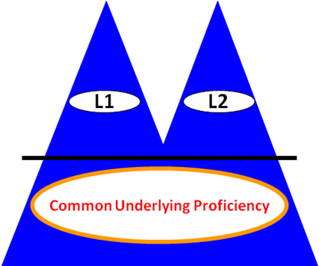

L1 = mother tongue

L2 = additional language

**Common Underlying Proficiency**

Thanks to this concept, we are now able to argue for the need to encourage bilingual learners to maintain and use their first language in the process of acquiring a second. One classroom teacher wrote:

“As far as possible, I use students’ first language often in my teaching because I believe that bilingualism is an asset, and the first language has a significant and continuing role in identity, learning and the acquisition of additional languages. I also make sure that cognitive challenge is kept appropriately high during the lessons through an inclusive curriculum.”

**Part Three: Preparing for New Arrivals**

**1. New Arrivals Induction flowchart**

Pupil/family arrive at school Admin obtain basic information

School contacts New Arrivals & Travellers central Team, if for instance, the assistance of a translator (or any other services) is needed.

School arrange date for parents to meet the EAL Coordinator and have a tour of the school.

EAL Coordinator to begin class preparations and inform all relevant staff and class teachers.

Welcome parents, welcome new pupil. Ensure as much involvement in class as possible in the first few weeks.

Contact the EMA central team if support is required in terms of training, consultancy or peripatetic placement.

EMA department Carry out an initial EAL assessment within the first two weeks in school, draw an Individual Language Plan, and copies are shared with class teachers.

(See Appendices 1-4 re Initial EAL Assessment documents).

Planning for in-class support especially in core subjects

Intensive language support through withdrawal

School continue to develop partnerships with home and community.

**2. Induction Check list**

This is a suggested resource to support the person in charge of the induction who needs to make sure that the pupil and her/his family are well informed of everything in the checklist. Please see your school planner for the page numbers relevant to each section in the checklist.

|  |  |  |
| --- | --- | --- |
|  | **Page on school planner** | **Tick/Cross** |
| **Equipment** | P |  |
| **Uniform** | P |  |
| **Planner** |  |  |
| **School day** | P |  |
| **School calendar** | P |  |
| **School map** |  |  |
| **School expectations** | P |  |
| **Classroom rules** | P |  |
| **Buddy** |  |  |
| **Lunch time** |  |  |
| **Staff room information board** |  |  |
| **Head of Year** | P |  |
| **EMA Staff** |  |  |
| **Bus timetable** |  |  |
| **Parent’s/carer’s signature** | P |  |

**3. Subject Area Signs**



**Design technology**

**Geography**



**Religious Education**



**Art**

**History**



**Music**



**Science**

**Urdu**



**Literacy**

**Numeracy**



**English**



**Information Technology**

**French**

**Sport**



**Spanish**



**Citizenship**



**4. Signs for school day activities**

**Registration**



**Assembly**



**Break**



**Lunch time**

**End of school day**



**Part Four: EAL Initial Assessment and Intensive Language Support**

**1. Initial EAL assessment**

Once the induction process is over and the newly arrived pupil is settled into whole school routine, an initial assessment is carried out. The model proposed as part of this guidance is given as a framework covering the necessary requirements for developing a clear picture as to the assessed pupil’s current stage of learning English. The assessment should cover not only the four attainment targets, speaking, Listening, reading and Writing but also the pupil’s background knowledge in Maths and Science and their cognitive skills.

The initial assessment is based on the NASSEA model of step levels. Therefore, the assessed pupil may come under one of three groups: steps 1&2 (beginner), steps 3&4 (intermediate) and steps 5&6 (advanced). The assessor will decide from the outset especially through the first contact with the pupil, the induction process or the questions in the introduction to the test (see page 3), at what sort of level the pupil should assessed. Consequently, if the pupil is a beginner, only section one i.e. steps 1&2 is used. After the assessment of each attainment target, a table of the NASSEA step levels is provided which helps the assessor to assign the appropriate level based on the evidence gathered in the course of the assessment of the relevant attainment target. This is followed by a small table where the pupil’s level of attainment according to the national curriculum standards and NASSEA step levels is registered as well as long term aim, short term targets and some teaching strategies.

**2. Targets and teaching strategies**

In order to set the targets and to suggest some teaching strategies, we refer you to a very useful document (appendix %) which provides examples according to each NASSEA step level. This will complete the assessment process when the results are stored and shred with relevant school staff especially the teaching staff.

Based on the evidence afore mentioned (see the section on common underlying proficiency), if resources permit, it is also worth carrying out an assessment of the pupil’s skills in using their mother tongue. This in principle should complement the initial EAL assessment and shed more light on a pupil’s levels of competence thereby avoiding the classic mistake of putting an EAL pupil in the lower groups or the SEN group.

**3. Individual Language Plan (ILP)**

Depending on the level of concern or the resources, it is recommended that after the assessment an ILP is drawn out using the document in appendix % Targets and Teaching strategies. The ILP pro forma in appendix x is a suggestion.